Week 1 Task Documentation:

Data Acquisition, Cleaning, and Exploratory Analysis

Project Title: E-Commerce Basket & Customer Analytics
Domain: E-Commerce & Retail Analytics
Estimated Completion Time: 30–35 Hours

1. Executive Summary & Objective
The primary objective of this Week 1 project is to simulate an end-to-end data preparation and exploratory data analysis (EDA) pipeline for a retail analytics environment. Working across two relational datasets—basket_details.csv (15,000 purchase records) and customer_details.csv (20,000 customer profiles)—this project focuses on:
- Auditing and resolving data quality issues (corrupted demographic records, invalid negative ages, and out-of-range outliers).
- Standardizing schema types (converting raw date strings to native datetime objects).
- Merging relational tables on unique customer identifiers (customer_id).
- Conducting exploratory data analysis (EDA) through descriptive statistics and visualizations to extract actionable business insights.
Note:-The CSV files are taken from kaggle.com

2. Data Cleaning & Preprocessing Methodology

2.1 Identified Data Quality Issues & Rationale
Initial exploration using Pandas identified critical data hygiene anomalies:
- Invalid Customer Ages: The raw customer_age field contained extreme values ranging from -34.0 (negative age error) to 2022.0 (corrupted birth year recorded as age). This resulted in an uncleaned mean age of 262.22 years.
- Imputation Strategy: A strict validity boundary was established: 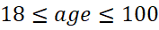. All invalid values outside this range were replaced with the median age of valid customer records (34.0 years). This median imputation preserved overall sample size while restoring normal distributional behavior.
- Type Conversion & Merging: basket_date was converted to datetime64[ns]. Deduplication was performed across both datasets before executing an inner join on customer_id.

3 Code Snippet: Python Preprocessing Pipeline
import os
import matplotlib.pyplot as plt
import numpy as np
import pandas as pd
import seaborn as sns
# 1. Load Data
basket_df = pd.read_csv('basket_details.csv')
customer_df = pd.read_csv('customer_details.csv')
# 2. Convert Data Types
basket_df['basket_date'] = pd.to_datetime(basket_df['basket_date'])
# 3. Handle Age Outliers via Median Imputation
valid_median = customer_df.loc[
(customer_df['customer_age'] >= 18) & (customer_df['customer_age'] <= 100),
'customer_age',
].median()
customer_df_cleaned = customer_df.copy()
customer_df_cleaned['customer_age_cleaned'] = customer_df_cleaned[
'customer_age'
].apply(lambda age: age if 18 <= age <= 100 else valid_median)

# 4. Deduplicate and Merge
basket_df_cleaned = basket_df.drop_duplicates()
customer_df_cleaned = customer_df_cleaned.drop_duplicates()

merged_df = pd.merge(
basket_df_cleaned, customer_df_cleaned, on='customer_id', how='inner'
)

Visualization 1: Data Quality & Age Distribution (Raw vs. Cleaned)
- Description: A comparative plot contrasting the raw boxplot (distorted by extreme outliers like age 2022) with the cleaned distribution histogram using Kernel Density Estimation (KDE).
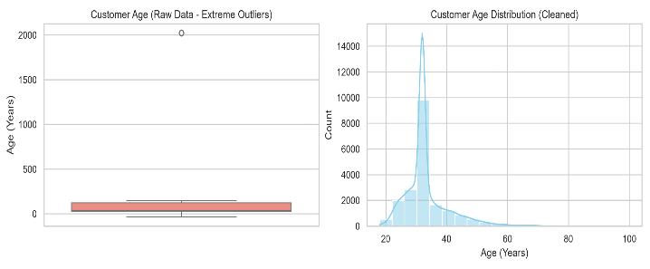
- Analytical Finding: Cleaning converted a corrupted distribution into a right-skewed distribution centered at a median age of ~34 years.

Visualization 2: Variable Correlation Matrix Heatmap
- Description: A heatmap measuring pairwise linear correlation coefficients () between basket_count, customer_age_cleaned, and tenure.
- Analytical Findings:
  - Age vs. Tenure (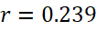): Slight positive correlation indicating older customers tend to have longer account relationships.
  - Basket Count vs. Tenure (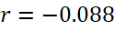): Near-zero correlation, indicating that account tenure does not automatically translate to larger order volumes per basket.
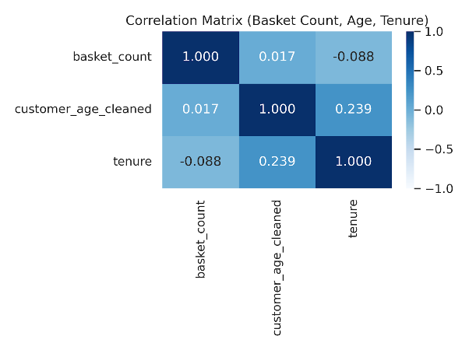

Visualization 3: Daily Total Basket Items Purchasing Trend
- Description: A time-series line chart tracking aggregated daily item volume across the transaction period.
- Analytical Finding: Purchasing volume peaked in late May 2019 (reaching 18 items/day) before settling into a baseline averaging ~2–5 items per day in June.
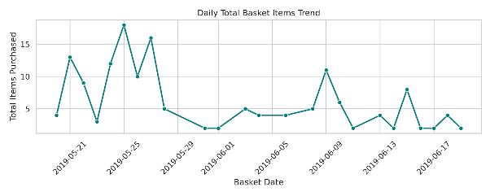

5.Summary of Insights & Next Steps
- Demographic Target: The primary purchasing demographic centers between 25 and 45 years of age (median = 34.0 years). Marketing campaigns should focus product positioning around this tier.

- Basket Optimization: Order sizes remain constant across both new and existing customers (~2 items per transaction). Cross-selling tactics or minimum purchase thresholds (e.g., "Free shipping over 4 items") can be used to drive higher transaction values.

